E Track Survey Report

### **Fall 2020 Pre Survey:(No post Survey)**

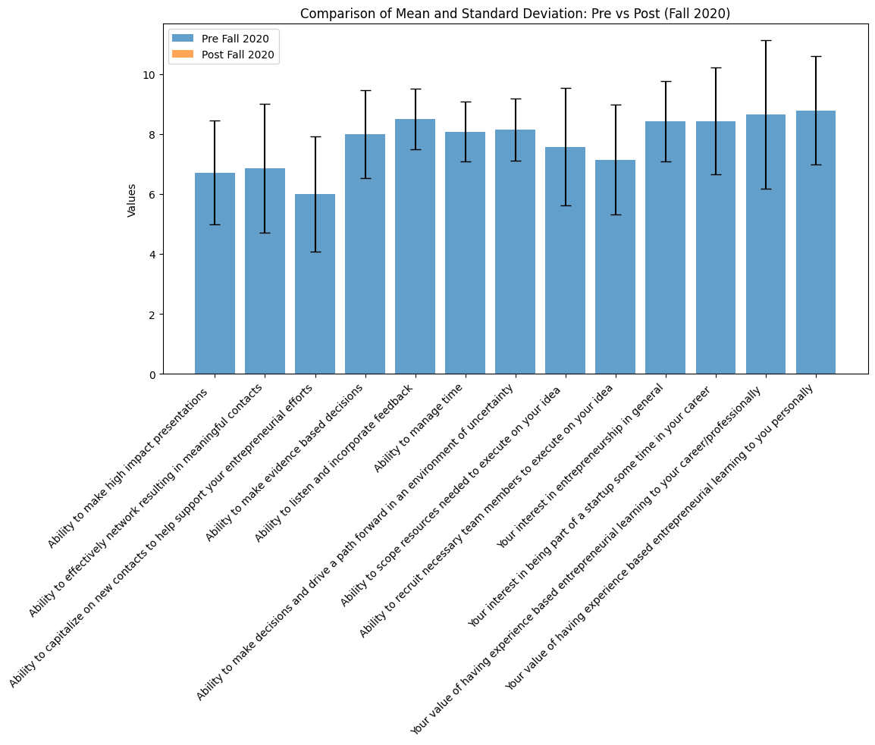

**Spring 2021 Pre and Post Survey Metrics:**

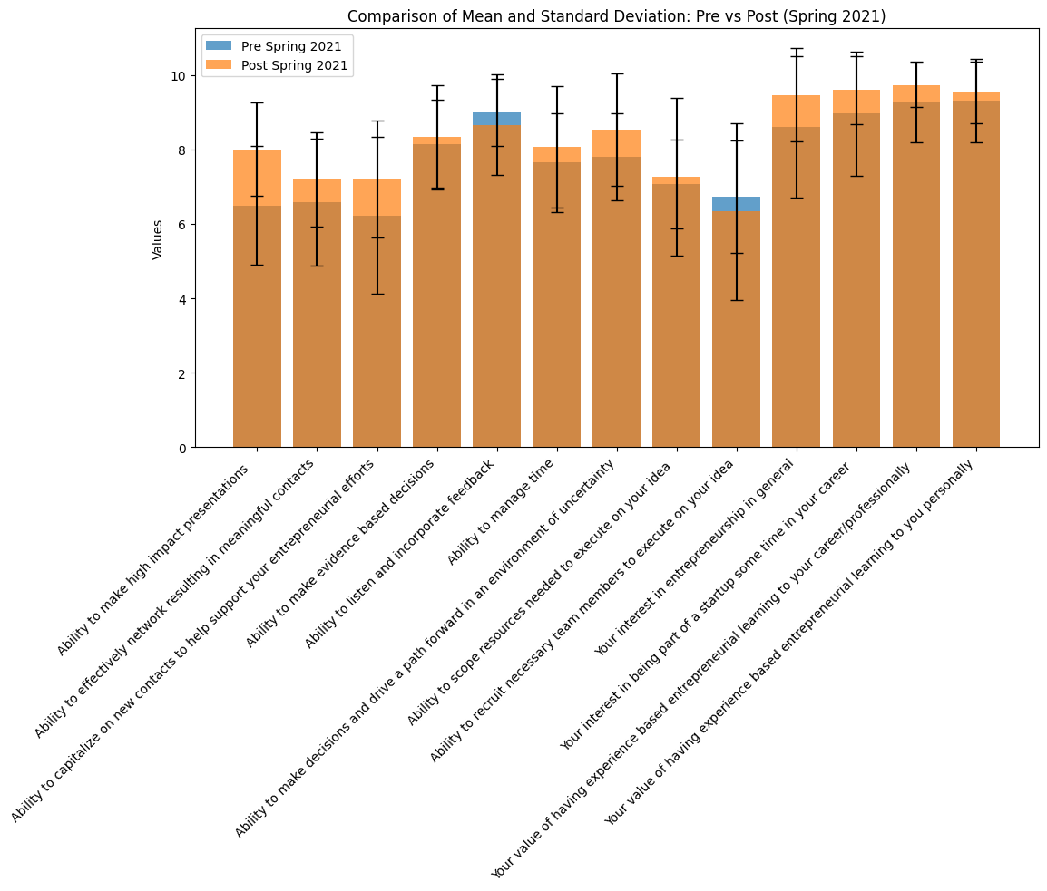

**Summer 2021 Pre and Post Survey Metrics:**

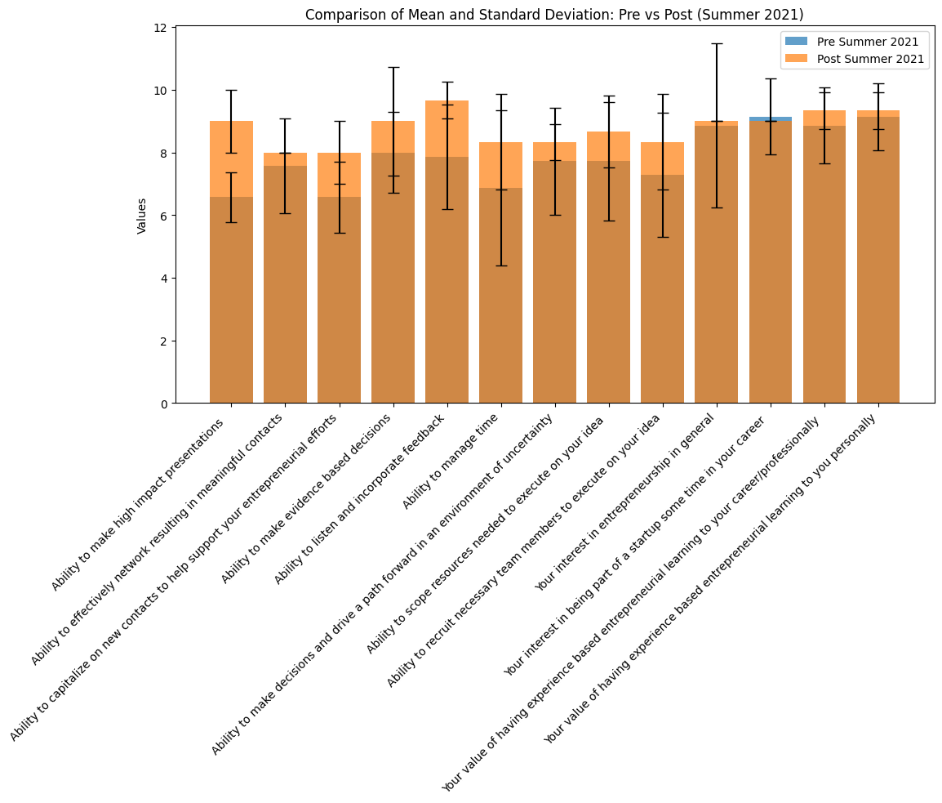

**Fall 2021 Pre and Post Survey Metrics:**

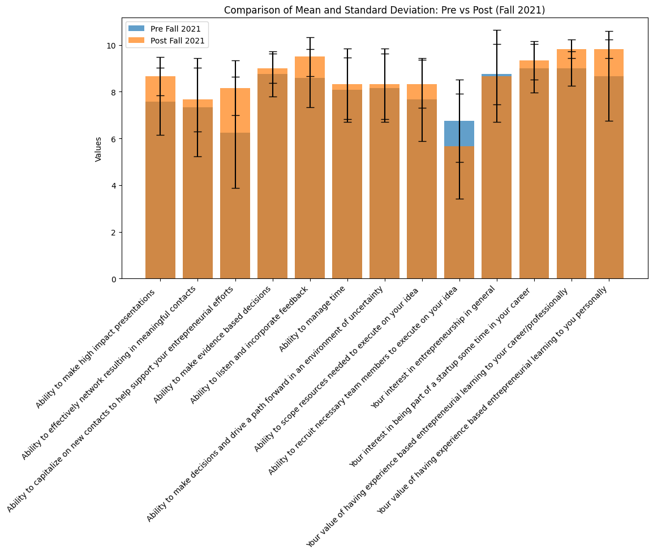

**Spring 2022 Pre and Post Survey Metrics:**

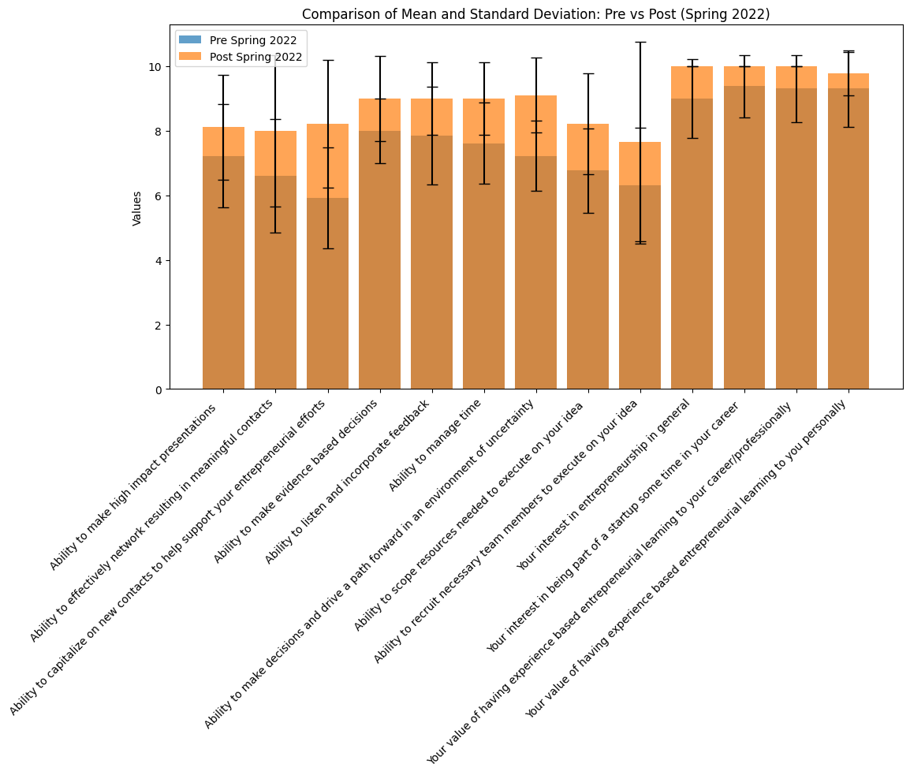

**Summer 2022 Pre and Post Survey Metrics:**

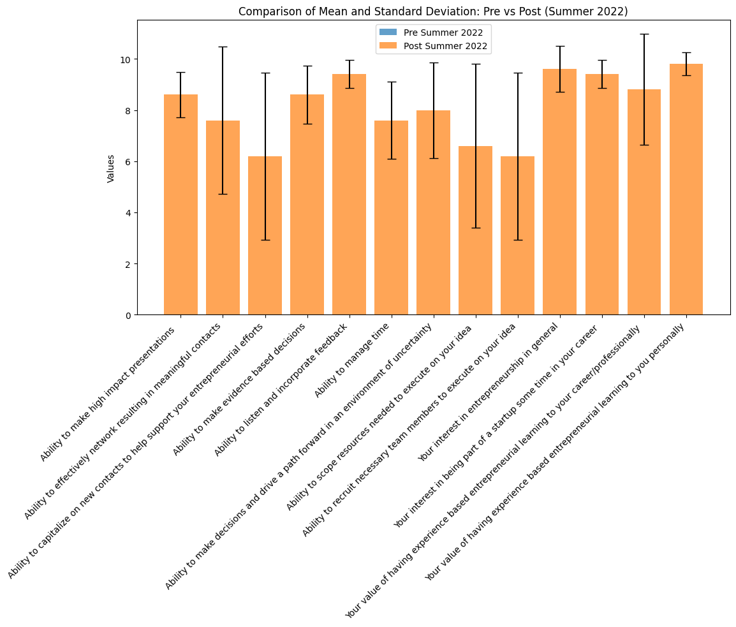

**Fall 2022 Pre and Post Survey Metrics:**

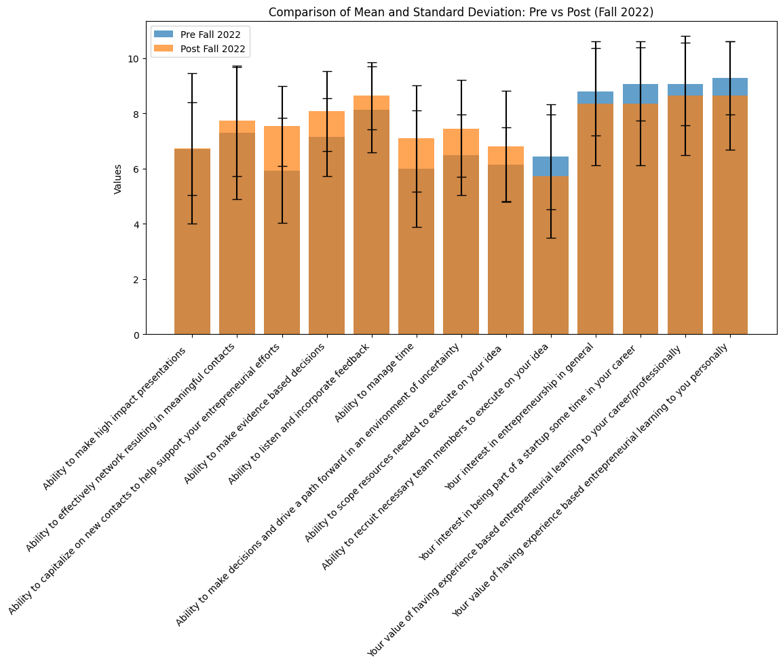

**Spring 2023 Pre and Post Survey Metrics:**

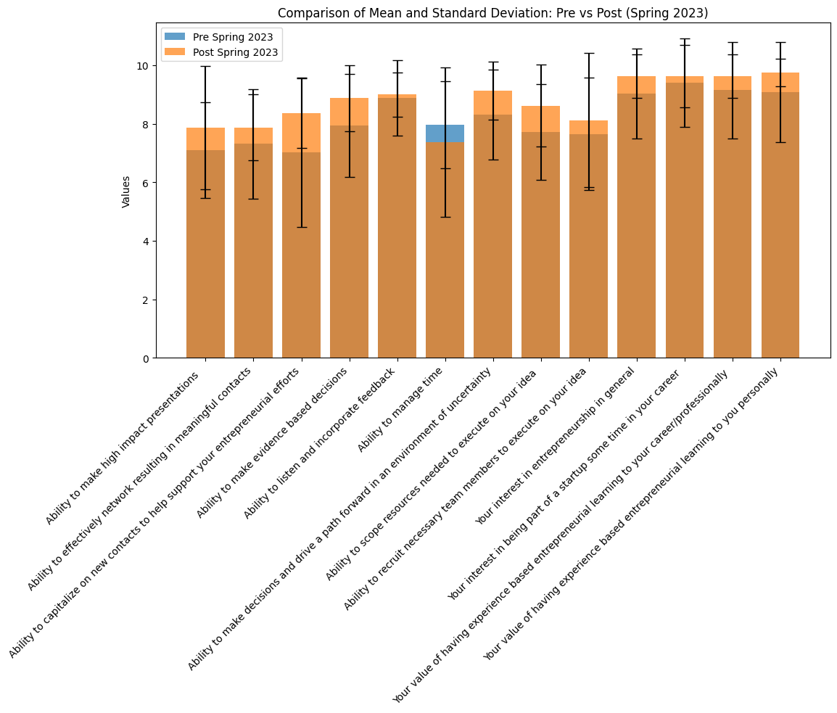

**Summer 2023 Pre and Post Survey Metrics:**

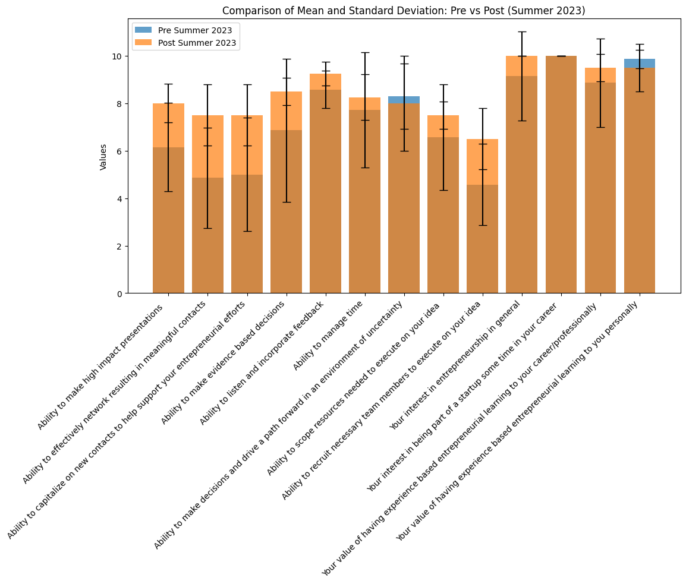

**Fall 2023 Pre and Post Survey Metrics:**

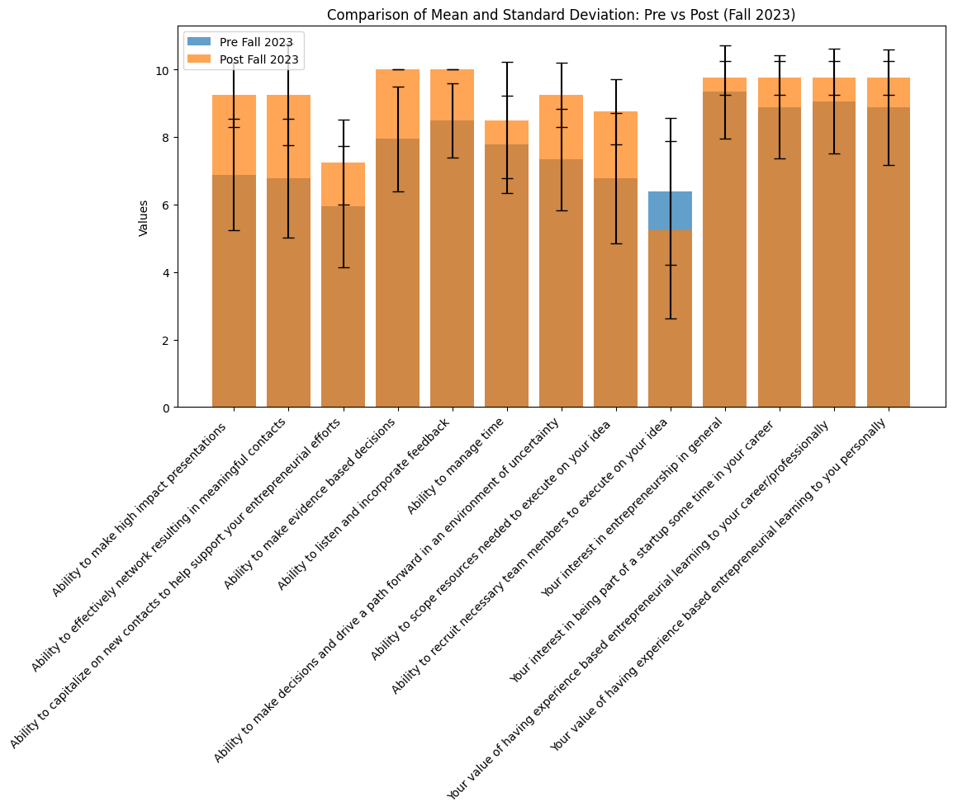

**Spring 2024 Pre and Post Survey Metrics:**

